**A PROJECT REPORT**

**ON**

**HUMAN DROWSINESS DETECTION**

Submitted for partial fulfillment of the requirements.

for the award of the degree of

Bachelor of Technology

in

Computer Science

**Submitted by**

Daksh Kumar (2000290120060)

Ashu Verma (2000290120045)

Chandan Kumar Gupta (2000290120058)

**Under Supervision of**

Dr. Kalpna Sagar



**KIET Group of institution, Ghaziabad**

**Dr. A.P.J. Abdul Kalam Technical University, Lucknow**

**April, 2024**

|  |  |
| --- | --- |
| **TABLE OF CONTENTS** | **Page No.** |
| DECLARATION……………………………………………………………………. |  |
| CERTIFICATE……………………………………………………………………… |  |
| ACKNOWLEDGEMENTS…………………………………………………………. |  |
| ABSTRACT……………………………………………………………………….... |  |
| LIST OF FIGURES…………………………………………………………………. |  |
| LIST OF TABLES…………………………………………………………………… |  |
| LIST OF ABBREVIATIONS………………………………………………………. |  |
|  |  |
| CHAPTER 1 INTRODUCTION  1.1 Introduction to Project  1.2 Project Category  1.3 Objectives  1.4 Structure of Report  CHAPTER 2 LITERATURE REVIEW  2.1 Literature Review  2.2 Research Gaps  2.3 Problem Formulation  CHAPTER 3 PROPOSED SYSTEM  3.1 Proposed System  3.2 Unique Features of The System  CHAPTER 4 REQUIREMENT ANALYSIS AND SYSTEM SPECIFICATION  4.1 Feasibility Study (Technical, Economical, Operational)  4.2 Software Requirement Specification  4.2.1 Data Requirement  4.2.2 Functional Requirement  4.2.3 Performance Requirement  4.2.4 Maintainability Requirement  4.2.5 Security Requirement  4.3 SDLC Model Used  4.4 System Design  4.4.1 Data Flow Diagrams  4.4.2 Use Case Diagrams  4.5 ER Diagram  CHAPTER 5 IMPLEMENTATION  5.1 Introduction Tools and Technologies Used.  CHAPTER 6 TESTING, AND MAINTENANCE  6.1 Testing Techniques and Test Cases Used  CHAPTER 7 RESULTS AND DISCUSSIONS  7.1 Presentation of Results (Charts/Graphs/Tables)  7.2 Performance Evaluation  7.3 Key Findings  CHAPTER 8 CONCLUSION AND FUTURE SCOPE  REFERENCES (Only **in IEEE FORMAT**)  Research Paper Acceptance Proof  Proof of patent publication (Screenshot of Publication) |  |
|  |  |

**DECLARATION**

We hereby declare that this submission is our work and that, to the best of our knowledge and belief, it contains no material previously published or written by another person nor material which to a substantial extent has been accepted for the award of any other degree or diploma of the university or other institute of higher learning, except where due acknowledgement has been made in the text.

Signature of Student:

Name: Ashu Verma

Roll No.: 2000290120045

Date: 07-05-2024

Signature of Student:

Name: Chandan Kumar Gupta

Roll No.: 2000290120058

Date: 07-05-2024

Signature of Student:

Name: Daksh Kumar

Roll No.: 2000290120060

Date: 07-05-2024

**CERTIFICATE**

This is to certify that Project Report entitled “**Human Drowsiness Detection**” which is submitted by **Ashu Verma, Chandan Kumar Gupta, Daksh Kumar** in partial fulfilment of the requirement for the award of degree B. Tech. in Department of Computer Science of Dr A.P.J. Abdul Kalam Technical University, Lucknow is a record of the candidates own work carried out by them under my supervision. The matter embodied in this report is original and has not been submitted for the award of any other degree.

**Date: 07-05-2024 Supervisor Signature**

**Dr. Kalpna Sagar**

**(Assistant Professor, CS)**

**ACKNOWLEDGEMENT**

It gives us a great sense of pleasure to present the synopsis of the B. Tech Mini Project undertaken during B.Tech. Third Year. We owe a special debt of gratitude to **Dr. Kalpna Sagar (Assistant Professor)** Department of Computer Science, KIET Group of Institutions, Delhi- NCR, Ghaziabad, for her constant support and guidance throughout the course of our work. Her sincerity, thoroughness and perseverance have been a constant source of inspiration for us. It is only his/her cognizant efforts that our endeavors have seen the light of the day.

We also take the opportunity to acknowledge the contribution of Dr. Ajay Kumar Shrivastava, Head of the Department of Computer Science, KIET Group of Institutions, Delhi- NCR, Ghaziabad, for his full support and assistance during the development of the project. We also do not like to miss the opportunity to acknowledge the contribution of all the faculty members of the department for their kind assistance and cooperation during the development of our project.

Last but not the least, we acknowledge our friends for their contribution to the completion of the project.

Signature:

Name: Ashu Verma

Roll No.: 2000290120045

Date: 07-05-2024

Signature:

Name: Chandan Kumar Gupta

Roll No.: 2000290120058

Date: 07-04-2024

Signature:

Name: Daksh Kumar

Roll No.: 2000290120060

Date: 07-05-2024

**ABSTRACT**

In this project we are trying to develop a system which will detect fatigue of the human and it will give warning. Due to drowsiness, office employees are not able to meet the deadlines of the projects allotted to them. Due to the drowsiness in offices the cost of company increases due to the delay in their projects. In this project the system will continuously monitor the eye of the human using a camera. By applying a perfect algorithm, we can detect the symptoms of drowsiness in peoples, and we will give a warning to avoid the person to get into sleep. In this project the warning will only be deactivated manually. For this a deactivation dialog box will appear which will have some basic operation for employee or we can add a device which will give an alert signal and that signal will stop only when the employee manually deactivates the signal. Moreover, if the person is drowsy, he/she may give the wrong answer in the dialog box. We can judge this by plotting a graph in time domain. If all the three input variables show a possibility of fatigue at one moment, then a warning is given in form of text or sound. This will directly give an indication of drowsiness.

**LIST OF FIGURES**

|  |  |  |
| --- | --- | --- |
| **FIGURE NO.** | **DESCRIPTION** | **PAGE NO.** |
| 4.1 | Data flow diagram (Level 0) |  |
| 4.2 | Data flow diagram (Level 1) |  |
| 4.3 | Use Case diagram |  |
| 4.4 | ER diagram |  |
| 7.1 | Human in sleepy state |  |
| 7.2 | Human in alert state |  |

**List of Tables**

|  |  |
| --- | --- |
| **Table No.** | **Table Name** |
| 2.1 | Analysis of different parameters used |
| 7.1 | Comparison Of Accuracy |

**LIST OF ABBREVIATIONS**

|  |  |
| --- | --- |
| **Abbreviation** | **Definition** |
| EEG | Electroencephalography |
| ECG | Electrocardiography |
| CNN | Convolutional Neural Networks |
| SVM | Support Vector Machine |
| CV | Computer Vision |
| EAR | Eye Aspect Ratio |
| CMTK | Microsoft cognitive toolkit |
| ROI | Return on investment |

**CHAPTER 1: INTRODUCTION**

* 1. **Introduction to Project**

Drowsiness behaviors which are related to fatigue are in different forms like eyes closed, head nodded or different brain activity. Due to the problem of drowsiness many companies face failure issues. So, we can either measure change in physiological signals, such as heart rate or blinking of eyes to monitor drowsiness. All the former technique, which are more accurate are not realistic for example Electroencephalography (EEG) and Electrocardiography (ECG) may not be practical options as they necessitate specialized equipment and the application of highly sensitive electrodes directly onto the individual. This method of detecting drowsiness will be very annoying and distracting for a person. The second method for measuring drowsiness is by measuring physical changes like eyes open/closed, yawning which can be detected and measured using camera. By detecting the time of blinking of eyes one can say person is drowsy or not. Therefore, through ongoing monitoring of an individual's eyes, it becomes possible to identify signs of drowsiness, allowing for timely alerts and potential interventions to counteract drowsiness.

1. **Project Category**

A drowsiness detection system is a technology designed to monitor and assess the alertness level of individuals in real-time, primarily in contexts where attention and vigilance are critical. This project category encompasses the development and implementation of algorithms, sensors, and software solutions aimed at detecting signs of drowsiness or fatigue in individuals.

1. **Objective**

In this project we are going to develop a Sleep Detection System that is proposed as specific counter measures to control the drowsiness that are associated with an employee. In this system we will use different techniques for detecting employee’s drowsiness while working also it will give notification when an employee reaches at critical level of drowsiness. Detection can be done using facial expression and characteristics. In this detection we can use SVM and CNN. So, we can use either of the algorithms for this detection.

1. **Structure of Report**
2. **Introduction**: In this section, we provide a succinct overview of our human drowsiness detection project, outlining its objectives and significance. We highlight the project's aim to develop an efficient drowsiness detection system and its potential impact on user convenience and productivity.
3. **Literature Review**: The literature review delves into existing research and discourse surrounding drowsiness detection system. We analyze the evolution of drowsiness detection technology, discussing advancements, user experiences, and pertinent security and privacy concerns.
4. **Proposed System**: This chapter outlines our proposed drowsiness detection system, detailing its functionalities and the technologies utilized for its implementation. We elucidate the system's capabilities and how it addresses user requirements.
5. **Requirement Analysis and System Specification**: Here, we conduct a feasibility study of our proposed system and provide a detailed software requirement specification. We discuss the chosen SDLC model and its relevance to the project's development.
6. **Implementation**: In this section, we present an overview of the languages, tools, and technologies employed for implementing the drowsiness detection system. We delve into the libraries and algorithms utilized, offering insights into the implementation process and key modules.
7. **Testing and Maintenance**: This chapter focuses on testing techniques and methodologies utilized to ensure the functionality and reliability of our drowsiness detection system. We discuss unit testing, integration testing, functional testing, usability testing, and performance testing, along with details of the test environment.
8. **Results and Discussions**: Here, we provide a summary of the various modules comprising the voice assistant system and discuss the outcomes of our project. We analyze the results, interpret their implications, and offer insights into the findings.
9. **Conclusion:** In the conclusion, we encapsulate the project's objectives, achievements, and contributions. We reflect on key findings, discuss potential future research directions, and underscore the significance of our work.
10. **References:** The references section includes citations of relevant research papers, articles, and sources used throughout the report, ensuring transparency and academic integrity.

**CHAPTER 2: LITERATURE REVIEW**

1. **Literature Review**

In this study, the author attempts to address the issue that drivers who drive long distances without frequent breaks incur a high chance of experiencing fatigue, a condition that experts say they frequently fail to identify in time. Sleepy drivers in need of a break are responsible for approximately 25% of significant motorway accidents according to studies. This means that sleepiness is a bigger cause of road accidents than drunk driving. Attention assist has an extended speed range, can alert drivers to their current level of fatigue and the amount of time since their last break, has adjustable sensitivity, and, if a warning is issued, uses the COMAND navigation system to show the location of nearby service areas. The system conducts real-time processing of a live video feed obtained from the driver's front-facing camera. Upon estimating the driver's fatigue level, the system triggers the alarm mechanism to issue an alert. The researcher investigated about the machine learning and algorithms in this study it also includes supervised learning, unsupervised learning, and reinforcement learning. The objective of the study is to increase public understanding for machine learning and accelerate its involvement by developing theoretical frameworks, improving automated, learning capabilities, including diverse digital technologies, and advocating for personalized services. Artificial intelligence and science are developing at a rapid rate, which has opened new development options. Including the vast theoretical knowledge, include statistics and algorithm complexity, into computer-based machine technology enhances the functional attributes of artificial intelligence. This study delves into the exploration of detecting driver drowsiness for BCI applications using fNIRS, with an emphasis on leveraging deep learning techniques. Thirteen individuals without health complications participated to capture passive brain signals linked with drowsiness during a simulated driving scenario. Employing a continuous wave fNIRS setup, researchers measured brain activities, focusing particularly on the prefrontal and dorsolateral prefrontal cortices. The study utilized DNN to classify between alert and drowsy states. Convolutional neural networks (CNNs) were applied to color map images for both model training and testing. The objective was to identify optimal channels for detecting brain activity across time intervals of 0-1, 0-3, 0-5, and 0-1 seconds. The CNN achieved an accuracy of 99.3%, demonstrating its ability to discern between images representing drowsy and non-drowsy states. This suggested method shows potential in identifying drowsiness and determining the specific brain region for a passive BCI system. This research introduces an effective three-phase sleepiness detection approach. The three stages involve eye tracking, yawning detection, and facial feature detection using the Viola-Jones method. After facial detection, the system achieves illumination invariance by selectively isolating the skin portion and considering only the chromatic components to eliminate background interference based on skin tone. The tracking of eyes and detection of yawning are accomplished through correlation coefficient template matching. To classify subsequent frames into tiredness and non-fatigue states, and to trigger an alarm for the former if it surpasses the threshold time, a binary linear support vector machine classifier concatenates feature vectors from each phase. Numerous real-time trials illustrate the effectiveness of the proposed strategy in identifying drowsiness and alerting the driver. The system for determining an individual's level of drowsiness in real time is proposed in this research. By employing artificial intelligence to boost Human productivity, this method seeks to improve society. This system will watch the user's mouth and eyes using a simple webcam that has been coded and positioned right in front of the user to determine whether the user is sleepy. The device will buzz an alarm to notify the Human if it detects signs of tiredness, such as yawning and closed eyes. To identify the target area of the face, it makes use of the idea of image processing. To ascertain whether the subject is yawning and whether their eyes are closed, Open CV is interfaced with Python programming. This project's primary goal is to monitor every Human working online to boost productivity lost to exhaustion and drowsiness at work. The face's outline is first recognized, and then the dlib Library's Facial Landmark Detector file is used to locate the mouth and eyes. To ascertain if the eyes and lips are open or closed, their distance from one another is measured. It is recorded if the mouth is found open for a specified period and the eyes are found closed for the same period. The Human receives an alarm buzz if the same thing happens more than four times. The measurement of eye blinks and movements is accomplished using the EAR, which calculates the ratio of the eye's width to the span between its vertical and horizontal points. EAR has found applications across several areas of scientific research, such as identifying deception and assessing cognitive load. The analysis derived from EAR calculations provides valuable perspectives on different aspects of psychology and human conduct. OGDF serves as a method for designing and organizing graphs, enabling the visualization of complex networks and structures. This robust algorithm facilitates the creation of graph layouts that are both aesthetically pleasing and easily comprehensible. Naive halfway fusion is a method that combines the outputs from multiple convolutional networks by averaging them at the midpoint of the network architecture, before merging them for a final prediction. This technique leverages the distinct features learned by each convolutional network, presenting a straightforward way to boost the performance of a group of these networks. Nevertheless, certain applications might demand more sophisticated fusion strategies for optimal results.

**Table 2.1: Analysis of different parameters used**

|  |  |  |  |  |
| --- | --- | --- | --- | --- |
| **REFERENCES** | **METHOD USED** | **FEATURES-EXTRACTED** | **CLASSIFIER-USED** | **RESULT** |
| [3] | electroencephalography (EEG),  electromyography (EMG) are used | Different psychological features | Support Vector Machine and K-Nearest Neighbor | 89.7% |
| [11] | Used two methodologies convolutional neural network (CNN) and LSTM | Eye State, Rate of blink | Support Vector Machine | 97.2% |
| [12] | Support Vector Machine and Viola-Jones algorithm are used | Yawn, Movement of head and Eye closure | Support Vector Machine | 94.3% |
| [13] | Paper is reviewed and summarizes different machine learning techniques used | Eye closure rate, pose of head | Different Classifiers | Depend on different studies. |

* 1. **Problem Formulation**

In some corporate offices many projects meet failure, some due to the drowsiness. It is one of the problems through which companies faces failure of the project. In a company if there are employee which are sleepy in nature then the productivity of company decreases, also these employees are very slow and reaction time is very low. It leads to adverse impact on the productivity of a particular organization. Also, sleepy employees have worse adaptive nature. That means they will not be able to adapt changing situation easily. Additionally, these employees will have trouble for doing multitasking or there is a problem to quickly switch between different tasks that are provided within a company. These are the main problems that occur due to drowsiness. So, there should be a system that keeps real time record and alert to the respective person so that there should not be any problem due to drowsiness.

**CHAPTER 3: PROPOSED SYSTEM**

1. **Proposed System**

Our proposed system is entitled Employee Drowsiness Detection system. It is designed specifically for the employees working in organizations who feel drowsy in the working hours due to which sometimes there are delay in projects assigned to them. The system will work on principle of counter, wherein a limit (say 15) is set above which if the employee is found sleepy (or his/her eyes are closed), then alarm will be played, and data will be stored before the alarm goes on. The counter will increase based on the time for which the Employee’s eyes are shut. Also, it will track the productivity of the person by monitoring the keyboard activity done by the employee.

1. **Unique Features of The System**
2. Individualized Thresholds: The system can dynamically adjust drowsiness thresholds based on each employee's baseline alertness level, taking into account factors such as age, sleep patterns, and job demands. This personalized approach enhances the accuracy of drowsiness detection and minimizes false alarms.
3. Integration with Workstation Sensors: The system can integrate with sensors embedded in the employee's workstation, such as keyboard activity, mouse movement, and screen interaction. By analyzing these behavioral cues in conjunction with physiological signals like eye movements and heart rate variability, the system can provide a comprehensive assessment of drowsiness levels.
4. Real-time Feedback and Interventions: The system provides real-time feedback to employees, supervisors, and safety officers about their alertness levels. In addition to visual alerts on the computer screen or wearable devices, the system can trigger audible alarms, vibration alerts, or even temporarily disable high-risk tasks until the employee's alertness improves.
5. Fatigue Risk Management: Beyond detecting drowsiness in the moment, the system incorporates fatigue risk management principles to prevent fatigue-related accidents and errors before they occur. This includes scheduling optimization features, fatigue prediction algorithms, and fatigue risk assessment tools that help organizations proactively manage fatigue risks in the workplace.
6. Data Analytics and Reporting: The system collects and analyzes a wealth of data on employee alertness, fatigue patterns, and workplace factors contributing to drowsiness. Through advanced data analytics techniques, organizations can gain insights into trends, identify risk factors, and optimize workplace practices to enhance employee well-being and safety.

**CHAPTER 4: REQUIREMENT ANALYSIS AND SYSTEM SPECIFICATION**

1. **Feasibility Study (Technical, Economical, Operational):**

**4.1.1 Technical Feasibility:**

* Assessment of the technical feasibility of developing and implementing the drowsiness detection system.
* Evaluation of the availability of necessary technology, resources, and expertise.
* Consideration of potential technical challenges and constraints.

**4.1.2 Financial Feasibility:**

* Estimation of the initial investment required for developing the drowsiness detection system.
* Projection of operating costs, including expenses for research and development, manufacturing, marketing, and distribution.
* Analysis of potential revenue streams and profitability, including sales projections and return on investment (ROI).

**4.1.3 Operational Feasibility:**

* Evaluation of the practicality and operational feasibility of implementing the drowsiness detection system.
* Assessment of organizational readiness and capacity for managing the project.
* Analysis of potential impacts on existing operations and workflows.

1. **Software Requirement Specification Document Which Must Include the Following:**

**4.2.1 Functional Requirements**

* The system shall monitor the employee's face using a camera or other appropriate sensor.
* The system shall detect yawning with an accuracy of at least 90%.
* The system shall give an alert when a yawn is detected.
* The system shall reset the alert when it detects that the employee has resumed working attentively.
* The system shall not generate false alarms due to factors such as eating, talking, etc.
* The system shall store a record of yawning events for later analysis and reporting

**4.2.2 Performance Requirements**

* The system must be able to detect drowsiness in real-time with a maximum latency of 1 second.
* The system must operate continuously for at least 4 hours without any performance degradation.

**4.2.3 Safety Requirements**

* The system must not distract the employee while working, and the feedback must not be too intrusive.
* The system must not interfere with the normal functioning of the system on which it is installed.

**4.2.4 Security Requirements**

* The system must use secure data storage and transmission protocols to protect the data collected during the working time.
* The system must be resistant to attacks such as tampering or spoofing of facial features.

1. **SDLC Model to Be Used:**

* **Iterative Development**: Agile methodologies, such as Scrum, emphasize iterative development cycles with frequent releases of working software. This approach allows for continuous improvement and refinement of the drowsiness detection algorithms and system functionalities based on ongoing feedback from users and stakeholders.
* **Flexibility**: The Agile approach prioritizes flexibility and adaptability to changing requirements and priorities. Given the dynamic nature of employee drowsiness detection, where new insights and user needs may emerge during the development process, Agile allows for adjustments to be made easily without disrupting the entire project timeline.
* **Cross-Functional Collaboration**: Scrum promotes close collaboration between cross-functional teams, including developers, testers, domain experts, and end-users. For an Employee Drowsiness Detection System, involving experts from various domains such as human factors engineering, data science, and occupational health is essential for developing a comprehensive solution that meets both technical and user requirements.
* **Rapid Feedback and Validation**: Agile methodologies facilitate rapid feedback loops and frequent validation of software functionalities through iterative development and continuous integration. This enables the development team to quickly identify and address issues related to drowsiness detection accuracy, system performance, and user experience, ensuring that the final product meets quality standards and user expectations.
* **Prioritization of Features**: Agile allows for the prioritization of features and functionalities based on their value to users and stakeholders. This enables the development team to focus on delivering the most critical aspects of the Employee Drowsiness Detection System first, while continuously iterating and adding new features in subsequent development cycles.

1. **System Design**

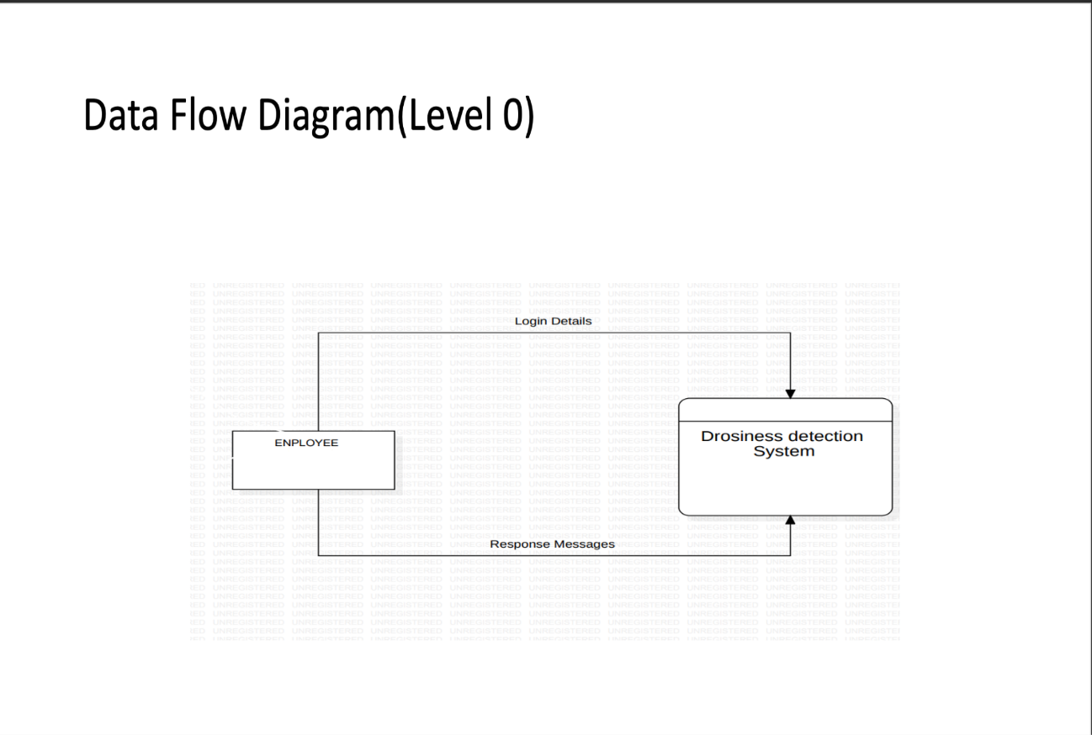**4.4.1 DFD Level 0 And Level 1**

**Fig 4.1: Data flow diagram (level 0)**

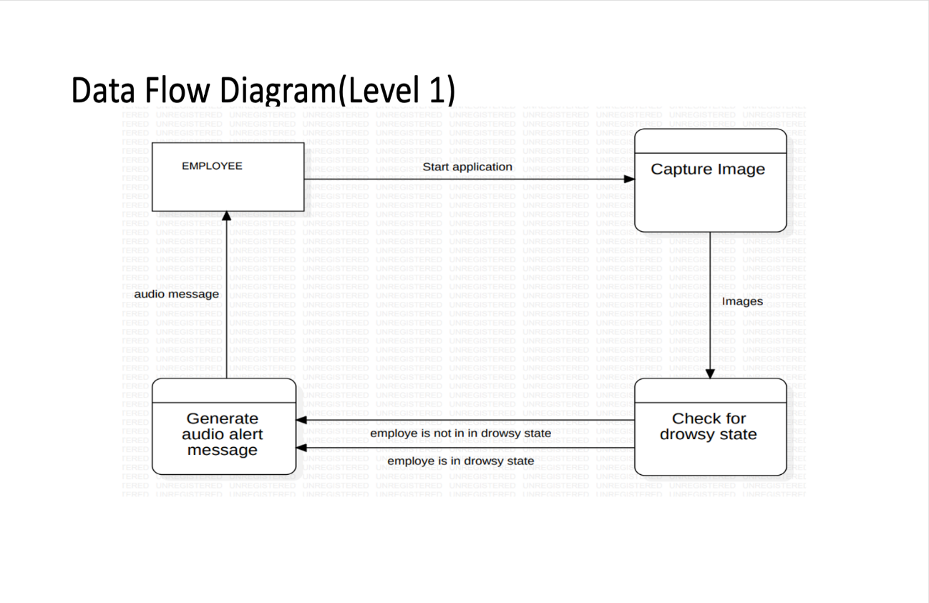**Fig 4.2: Data flow diagram (level 1)**

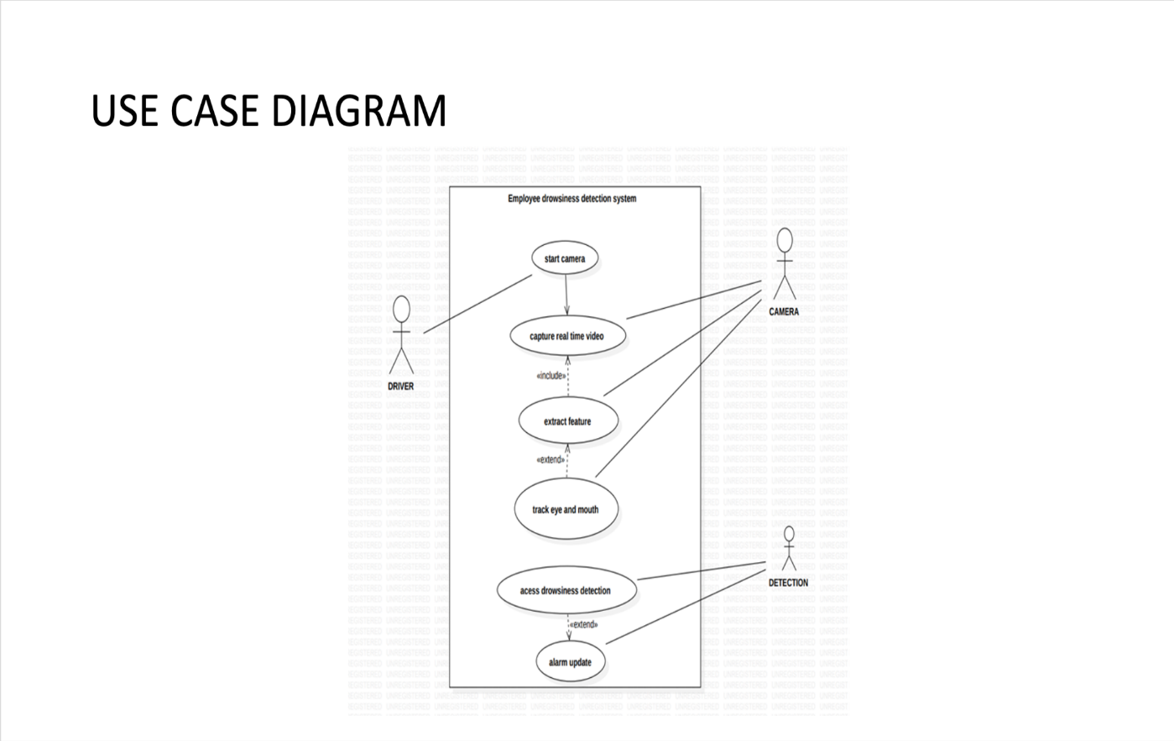**4.4.2 Use Case Diagram**

**Fig 4.3: Use Case Diagram**

1. **ER Diagram**

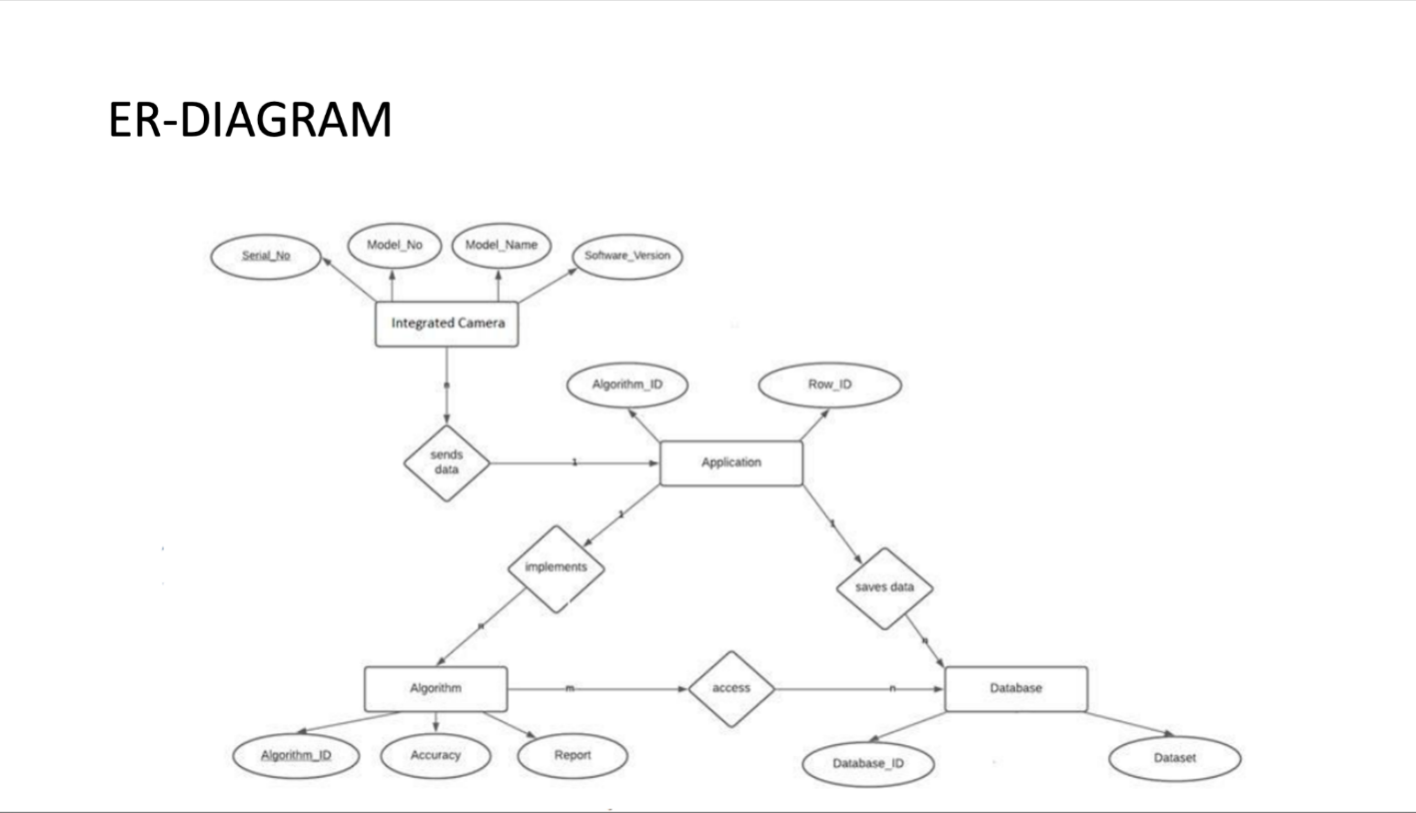

**Fig 4.4 : ER Diagram**

**CHAPTER 5: IMPLEMENTATION**

1. **Introduction to Languages, Tools, and Technologies Used for Implementation.**

The technology used for drowsiness detection is based on computer vision and machine learning algorithms that can process the images captured by a webcam or a built-in camera and recognize movement of eyeballs and yawning state. It uses open-source libraries like TensorFlow and OpenCV for the input and performing the calculations based on the provided input and work on bases of the machine learning algorithms. It does the recognition of eye’s state for computation. All the output is based on the given inputs and computations done by the applied algorithms.

1. **Python - Programming Language:**

* Python is a high-level, interpreted programming language known for its simplicity and readability.
* It has a vast ecosystem of libraries and frameworks, making it suitable for a wide range of applications, including web development, data analysis, machine learning, and more.

1. **PyTorch - Deep Learning Framework:**

* PyTorch is an open-source deep learning framework developed by Facebook's AI Research lab (FAIR).
* It provides a flexible and dynamic computational graph, making it easy to build and train neural networks.
* PyTorch is widely used for research and development in areas such as computer vision, natural language processing, and reinforcement learning.

1. **Keras - Deep Learning API for Pretrained Models:**

* Keras is a high-level neural networks API written in Python and capable of running on top of TensorFlow, Theano, or Microsoft Cognitive Toolkit (CNTK).
* It provides a user-friendly interface for building and training deep learning models, allowing for rapid prototyping and experimentation.
* Keras also includes pre-trained models and model architectures, making it easy to leverage state-of-the-art deep learning techniques.

1. **NumPy, Pandas - Data Handling and Manipulation:**

* NumPy is a powerful library for numerical computing in Python, providing support for multi-dimensional arrays and mathematical functions.
* Pandas is a data manipulation and analysis library built on top of NumPy, offering data structures like Data Frames for easy handling of structured data.
* Together, NumPy and Pandas form the foundation of data handling and manipulation in Python, making it easy to work with large datasets and perform complex data operations.

1. **Open CV:**

* Comprehensive suite of tools for computer vision and machine learning.
* Enables image and video processing tasks.
* Includes algorithms for object detection and recognition.
* Supports machine learning integration.

**CHAPTER 6: TESTING, AND MAINTENANCE**

1. **Testing Techniques and Test Cases Used**

Mention the reason of adopting a particular test methodology for the project. The test methodology selected for the project could be

1. **Waterfall Model:**

* The Waterfall model is a linear and sequential approach to software development, where each phase must be completed before moving on to the next.
* The phases typically include requirements analysis, system design, implementation, testing, deployment, and maintenance.
* It is characterized by its rigidity and predictability, with well-defined deliverables and milestones for each phase.

1. **Iterative Model:**

* The Iterative model is an incremental approach to software development, where the project is divided into small, manageable iterations or cycles.
* Each iteration encompasses the entire software development lifecycle, including requirements, design, implementation, testing, and deployment.

1. **Agile:**

* Agile is a set of principles and values for software development that prioritize flexibility, collaboration, and customer satisfaction.
* Agile methodologies, such as Scrum and Kanban, emphasize iterative development, continuous feedback, and adaptive planning.
* Agile teams work closely with stakeholders to deliver incremental value in short, time-boxed iterations called sprints.

1. **Extreme Programming (XP):**

* Extreme Programming (XP) is an Agile methodology that emphasizes engineering practices and collaboration within small, self-organizing teams.
* XP practices include test-driven development (TDD), pair programming, continuous integration, collective code ownership, and frequent releases.

**CHAPTER 7: RESULTS AND DISCUSSIONS**

1. **User Interface Representation**

The user interface for the Drowsiness Detection system will consist of the following components:

1. Camera: Camera will be mounted to capture the face of the employee.
2. Indicator: The system will use indicators to provide feedback to the employee. Green light will indicate that the employee is alert and red light will indicate that the employee is drowsy.
3. Database entry: The system will store the data of the employee in case of drowsiness.
4. User Interface: The system will have a simple and intuitive user interface for configuring and monitoring the system. It will allow the user to start and stop the system and adjust the settings.
5. Data display: The system will display data such as drowsiness level, time of detection, another alert issued on user interface.
6. Help Button: A help button will aid and contact support inn case of any issues or questions.
7. 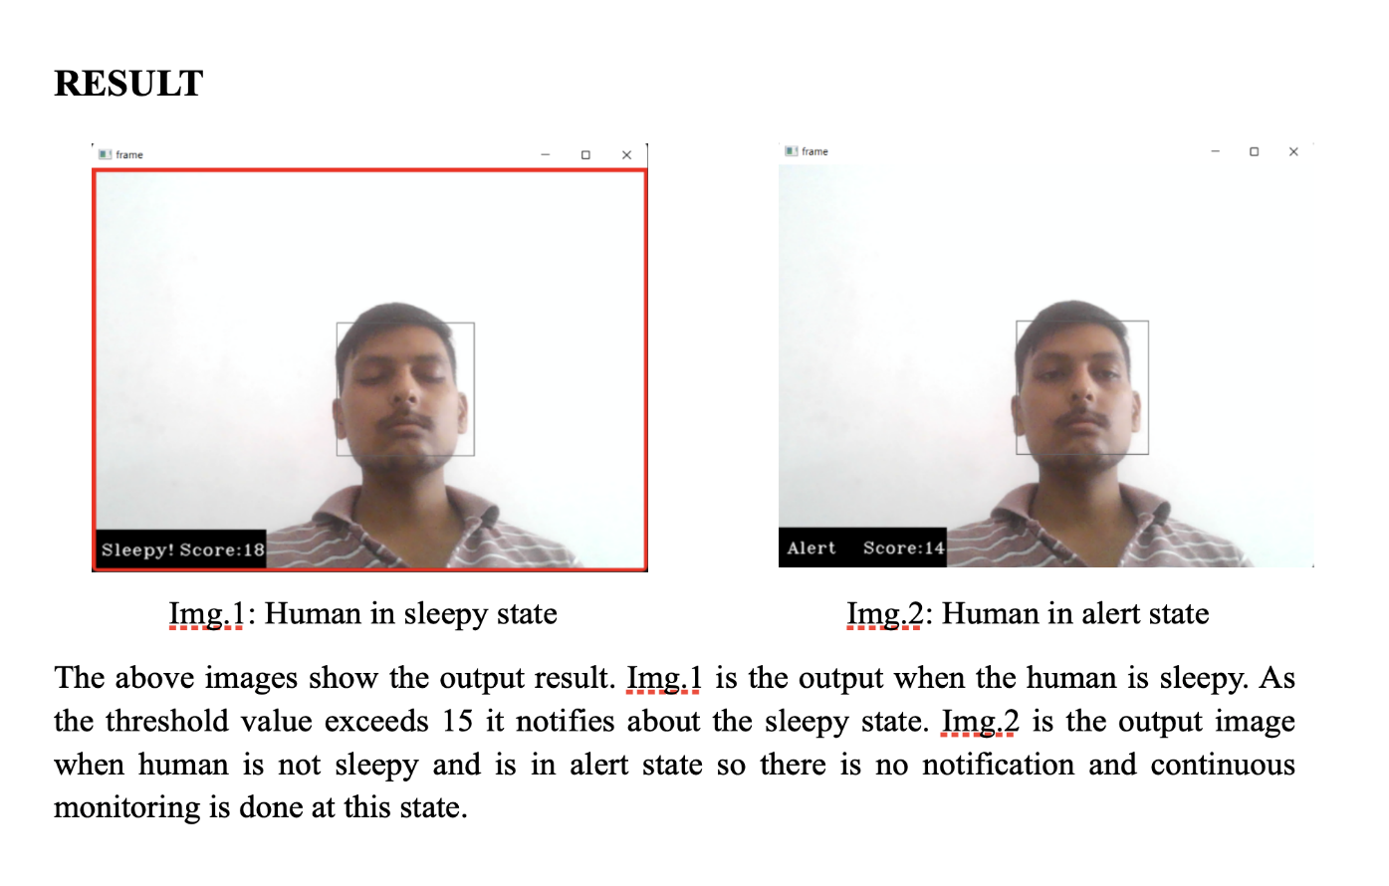**Snapshots of System with Brief Detail of Each**

**Fig 7.1: Human in sleepy state Fig 7.2: Human in alert state**

The above Figures show the output result Figure 5 is the output when the human is sleepy. As the threshold value exceeds 15 it notifies about the sleepy state. Figure 6 is the output image when the human is in alert state so, there is no notification and continuous monitoring is done at this state.

**Table 7.1: Comparison Of Accuracy**

|  |  |  |
| --- | --- | --- |
|  | **Accuracy of training** | **Accuracy of Validation** |
| **For CNN** | 98.01% | 93.07% |
| **For Transfer Learning** | 78% | 74% |

**CHAPTER 8 CONCLUSION AND FUTURE SCOPE**

1. **CONCLUSION**

In this project we can produce a system that will give notification if a person is feeling sleepy. Detection of drowsiness is done successfully. By making this project we have we can learn about TensorFlow and OpenCV. So, on my final count we added some extra fields by sending the daily drowsiness report to the HR department. It will also provide the productivity report of the employees based on the results obtained.

1. **FUTURE SCOPE**

It can be used for online education system, where recorded lectures can be monitored by using this drowsiness detection technique due to which productivity will increase and user can achieve higher level of understanding due to continue monitoring of eyes and facial expressions.

**REFERENCES (Only in IEEE Style)**

1. Jin, Wei. (2020). Research on Machine Learning and Its Algorithms and Development. Journal of Physics: Conference Series. 1544. 012003. 10.1088/1742-6596/1544/1/012003.
2. Saini, Vandna, and Rekha Saini. "Driver drowsiness detection system and techniques: a review." *International Journal of Computer Science and Information Technologies* 5.3 (2014): 4245-4249.
3. M. A. Tanveer, M. J. Khan, M. J. Qureshi, N. Naseer and K. -S. Hong, "Enhanced Drowsiness Detection Using Deep Learning: An fNIRS Study," in IEEE Access, vol. 7, pp. 137920-137929, 2019, doi: 10.1109/ACCESS.2019.2942838.
4. B. N. Manu, "Facial features monitoring for real time drowsiness detection," 2016 12th International Conference on Innovations in Information Technology (IIT), Al Ain, United Arab Emirates, 2016, pp. 1-4, doi: 10.1109/INNOVATIONS.2016.7880030.
5. A. Gadde, A. Gorde, A. Bopte, N. Kapgate, A. Nevatia and S. Choudhari, "Employee Alerting System Using Real Time Drowsiness Detection," 2022 10th International Conference on Emerging Trends in Engineering and Technology - Signal and Information Processing (ICETET-SIP-22), Nagpur, India, 2022, pp. 1-5, doi: 10.1109/ICETET-SIP-2254415.2022.9791811.
6. M. M. El-Barbary, G. S. Maximous, S. Tarek and H. A. Bastawrous, "Validation of Driver Drowsiness Detection Based on Human antenna Effect Using Facial Features," 2021 International Conference on Microelectronics (ICM), 2021, pp. 216-219, doi: 10.1109/ICM52667.2021.9664899.
7. M. Lu and F. Li, "Survey on lie group machine learning," in Big Data Mining and Analytics, vol. 3, no. 4, pp. 235-258, Dec. 2020, DOI: 10.26599/BDMA.2020.9020011.10.1109/ACCESS.20 20.3011360.
8. Shifeng Zhang(2019). A Dataset and Benchmark for Large-scale Multi-modal Face Anti-spoofing. In Xiaobo Wang2, Jian Liu, Chenxu Zhao, Jun Wan1, Sergio Escalera, Hailin Shi, Zezheng Wang, Stan Z, April 2019, DOI: 10.48550/ARXIV.1812.00408.
9. Wang, F. et al. (2018). 1. In: Ferrari, V., Hebert, M., Sminchisescu, C., Weiss, Y. (eds) Computer Vision – ECCV 2018. ECCV 2018. Lecture Notes in Computer Science, vol 11213. Springer, Cham
10. V Uma Maheswari, Rajanikanth Aluvalu, MVV Prasad Kantipudi, Krishna Keerthi Chennam, Ketan Kotecha, Jatinder kumar R. Saini. "Driver Drowsiness Prediction Based on Multiple Aspects Using Image Processing Techniques", IEEE Access, 2022
11. M. Asjid Tanveer, M. Jawad Khan, M. Jahangir Qureshi, Noman Naseer, Keum-Shik Hong. "Enhanced Drowsiness Detection Using Deep Learning: An fNIRS Study", IEEE Access, 2019
12. A. Amidei et al., "Driver Drowsiness Detection based on Variation of Skin Conductance from Wearable Device," 2022 IEEE International Workshop on Metrology for Automotive (MetroAutomotive), 2022, pp. 94-98, doi: 10.1109/MetroAutomotive54295.2022.9854871.
13. J. V. N. Lakshmi and A. Sheshasaayee, "Machine learning approaches on map reduce for Big Data analytics," 2015 International Conference on Green Computing and Internet of Things (ICGCIoT), Greater Noida, India, 2015, pp. 480-484, doi: 10.1109/ICGCIoT.2015.7380512.
14. Vijayan, Vineetha &amp; Elizabeth, Sherly. (2019). Real time detection system of driver drowsiness based on representation learning using deep neural networks. Journal of Intelligent &amp; Fuzzy Systems. 36. 1-9. 10.3233/JIFS-169909.
15. M. Babaeian, N. Bhardwaj, B. Esquivel and M. Mozumdar, “Real time driver drowsiness detection using a logistic- regression-based machine learning algorithm,” 2016 IEEE Green Energy and Systems Conference (IGSEC), Long Beach, CA, USA, 2016, pp. 1-6, doi: 10.1109/IGESC.2016.7790075.
16. M. Ngxande, J. -R. Tapamo and M. Burke, “Driver drowsiness detection using behavioral measures and machine learning techniques: A review of state-of-art techniques,” 2017 Pattern Recognition Association of South Africa and Robotics and Mechatronics (PRASA-RobMech), Bloemfontein, South Africa, 2017, pp. 156-161, doi: 10.1109/RoboMech.2017.8261140.
17. Watling, Christopher N., Md Mahmudul Hasan, and Grégoire S. Larue. “Sensitivity and specificity of the driver sleepiness detection methods using physiological signals: A systematic review.” Accident Analysis &amp; Prevention 150 (2021): 105900.

**Patent Status:**



**Research Paper :**

